Perseus and Medusa

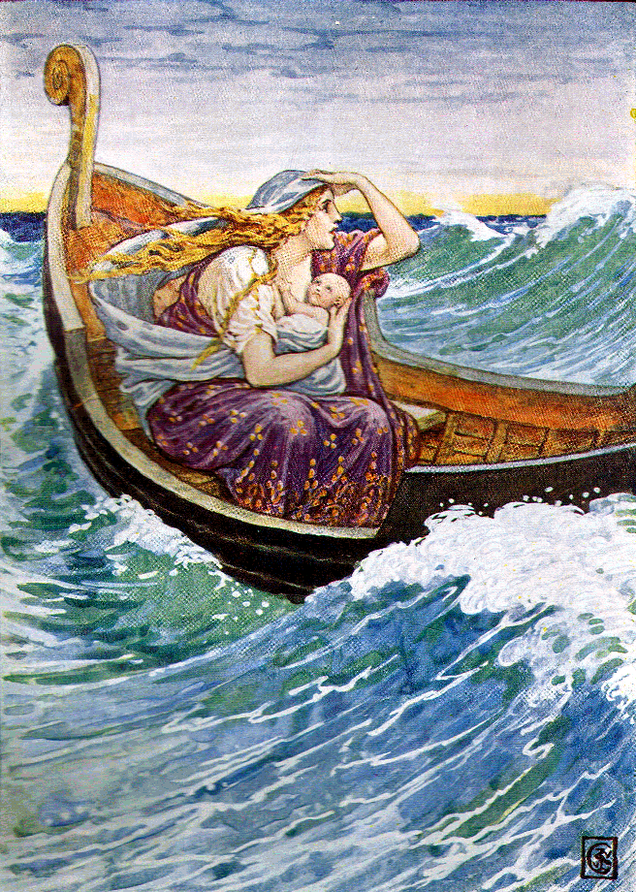
The King of Argos (Acrisius) was told by an oracle (prophecy) that his grandson would kill him one day. To keep his daughter, Danae, from marrying and having children he locked her in a room beneath the earth. One day Zeus came to her in the form of rain and caused her to have a child named Perseus. When the King of Argos heard this he did not believe that Zeus was Perseus’ father so he sent his daughter (Danae) and her small son (Perseus) out to sea in an ark (boat).

Later the ark came to the shores of Seriphos Island. A fisherman found Danae and Perseus. He knew by Danae’s clothes and her beauty that she was of royal blood and could not marry him, but he still cared for and adopted them. Danae learned to weave and worked in the fields. Perseus watched the goats and mended the fishing nets. Over the years he became a strong and good-looking young man.

One day the king of Seriphos (Polydektes) saw the beautiful Danae and wanted her for his wife, but he knew Perseus would protect his mother. For his birthday, Polydektes ordered everyone on the island to come to the palace with gifts. The fisherman knelt before the king and opened his sack, laying out fresh fish he had caught that morning and some goat cheese from his herd of goats. The king laughed at the fisherman saying, “You insult me with your fish and smelly cheese.” This made Perseus very, very mad and before his mother could stop him, he shouted, “If these gifts are not good enough for you, tell me what you want and I will bring it to you.” The king (Polydektes) laughed and thought how perfect this was for now he could send the young Perseus on a dangerous quest leaving his mother all alone. Polydektes said, “Far from here in the place where the sun god dips his chariot into the river of Okeanos and darkness (night) comes to the earth, there is a desert. There you will find three gorgons with the bodies of women, snakes for hair, teeth like the tusks of boars, and wings of gold. Many men have turned to stone upon looking into their faces. Bring me the head of the gorgon called Medusa.”

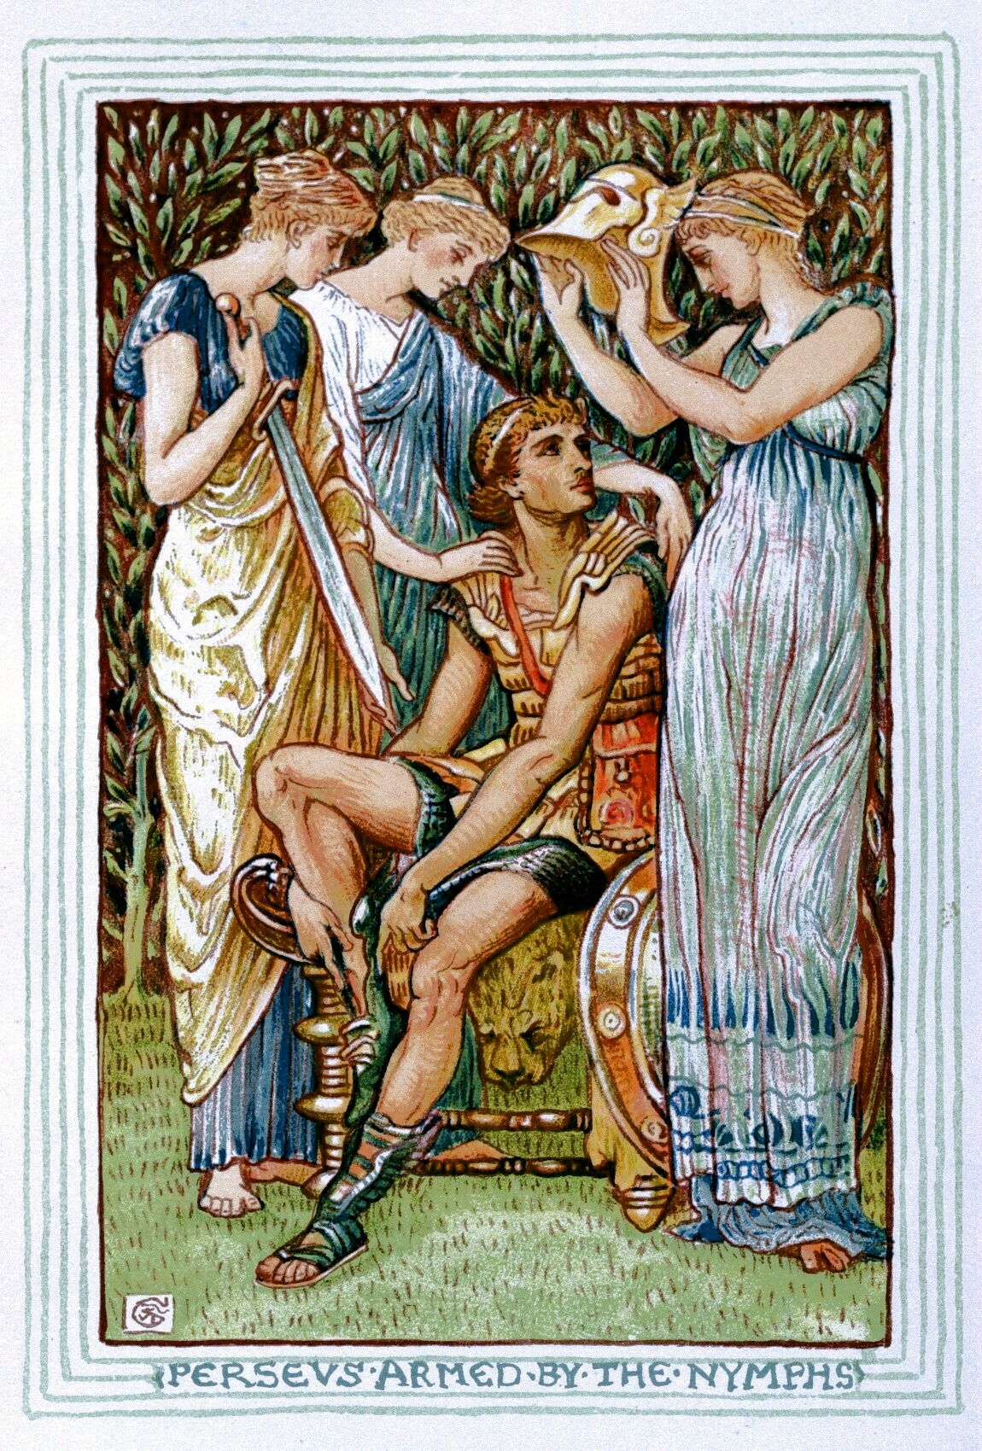
On Mount Olympus, Athena the goddess of war heard the king’s words and decided to help Perseus. She called Hermes, messenger of the gods, to give Perseus a sharp knife to cut off Medusa’s head. Some nymphs gave him a pair of winged sandals so he could fly, a magic helmet to make him invisible and a special pouch to keep Medusa’s head in if he was successful. Athena herself gave him one final gift. She handed him a shield. “It contains no magic, but it is vital (important) to your task.”
“It’s beautiful,” said Perseus admiring the gleaming shield. The bronze was so highly polished that he could see his face in it. “Use it as a mirror,” said the goddess and the young hero understood. Then Perseus set off with Hermes as his guide.

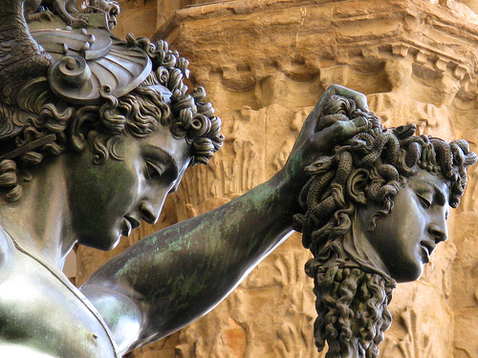
Soon he came to a desert, where no plant grew and bare rock stretched as far as the eye could see. Only the sun god gazed down on the land. High above the desert, Perseus soared searching for the gorgons. He found them sleeping in a sandy hollow below. Athena had sent the sleep god to make the gorgons sleepy. Entering the place where the three gorgons slept, Perseus squeezed through the silent crowd of stone victims. He knew if he so much as glimpsed any of their faces, he would turn to stone. Athena told him which gorgon was Medusa. He turned his face to one side and held his shield in front of the sleeping Medusa. Then with his eyes fixed firmly on the shield he made his way to her sleeping form. He pulled out the knife Hermes had given him and cut off Medusa’s head without ever having to look at the hideous creature. Perseus thrust the writhing head into his sack and flew away.

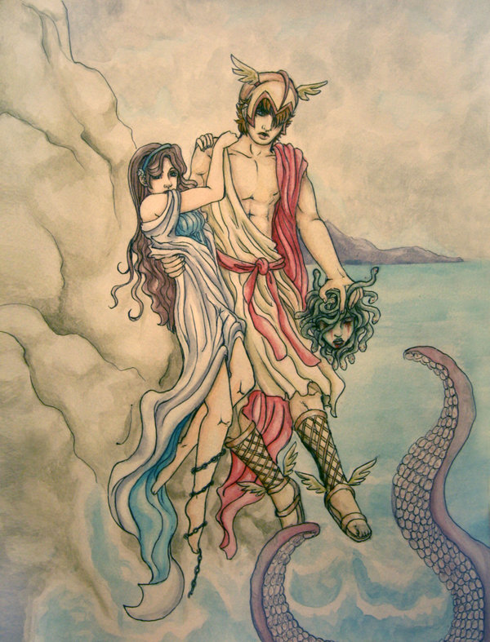
Hermes guided Perseus back to the land of humans. On his way home, far below him on a rocky finger of land sticking out into the sea, he saw a young woman (Andromeda) chained to a rock. A crowd of people had gathered on a nearby beach watching the crying woman. Suddenly, a dark shape appeared in the water. It burst from the sea and headed for the young woman. Perseus reached into his bag, grabbed Medusa’s head and dove from the sky turning the sea monster to stone. The people on the beach shouted for joy as Perseus unchained the princess from the rock and took her to the king. The king embraced his daughter and announced a royal wedding between his daughter, Andromeda, and Perseus.

A year later Perseus, with his new wife, arrived back in Seriphos. He found his mother gone and the old fisherman alone. The fisherman explained that because of King Polydektes his mother had taken shelter at the altar of Zeus. There the king and his men had surrounded her. Perseus left his wife, Andromeda, with the old fisherman; taking his bag with Medusa’s head and set off to find his mother.

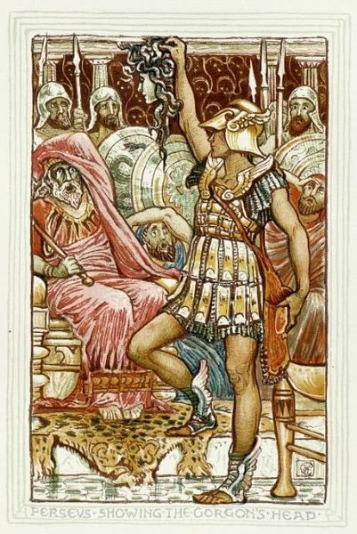
When King Polydektes saw Perseus he mocked him. “So you are back at last. It has taken you a long time to bring back my gift, but I am always happy to have a birthday present, even a late one. I suppose you have Medusa’s head in that little bag. I can’t say I think much of the wrapping!” The king and his men roared with laughter, but when Perseus drew Medusa’s head from the bag the laughter stopped as all turned to stone. Then Athena descended from above, taking Medusa’s head and placing it on her breast shield to paralyze her enemies.

Perseus made the faithful fisherman king of the island of Seriphos. Then taking his mother, Danae, and his wife, Andromeda, he headed for his birthplace to see his grandfather. When he arrived in Argos, the king was gone. The king had run away when he heard Perseus was returning and Perseus became the king of Argos.

Years later when Perseus was competing in an athletic competition, he threw a disc so hard it flew into a crowd killing an old man. No one knew who the old man was, so Perseus brought him back to Argos. When Perseus’ mother came to mourn, she looked down on the old man only to see lifeless face of her father.

Adapted from “Perseus and Medusa” by Richard Wolf and “Medusa – The Snake Haired Monster” as told by Philip Ardagh in World Book Ancient Greek Myths and Legends

Map of Ancient Greece

