Name ________________________________________ Period __________ Date _____________________

Quarter 1 Geography Study Guide

- Geography is the study of the Earth and its features.
- The 5 themes of Geography are: Location, Place, Movement, Regions, Human-Environment Interaction.
- There are 7 large land masses (surrounded by oceans) called Continents.
- One of the Earth’s five largest bodies of salt water is called an ocean.
- An island is land completely surrounded by water.
- A group of islands is called an Archipelago.
- Land next to a sea or an ocean is a called a coast.
- A mountain is a large elevation on the Earth’s surface.
- A large stream of natural origin that flows into another body of water is called a river.
- The horizontal lines on a map are called latitude lines.
- The vertical lines on a map are called longitude lines.
- Name the 4 hemispheres Northern, Southern, Eastern, and Western .
- The vertical line on a map of the world that separates the Eastern and Western Hemispheres (at 0°) is called the Primer Meridian.
- The horizontal line on a map that separates the Northern and Southern Hemispheres (at 0°) is called the Equator.
- Name 5 components of a good map: Title, Author, Compass, Scale, Key/Legend. date, symbols)

- Name all 8 points on the compass rose:

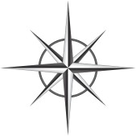

- Using the map scale find the actual distance from Washington DC to Austin, TX. You may use math or an index card to find your answer.

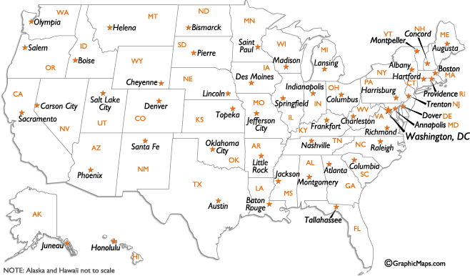

Scale
__________
0 500

- Use the map below and determine what continent is at 40°N and 140°E? Asia.

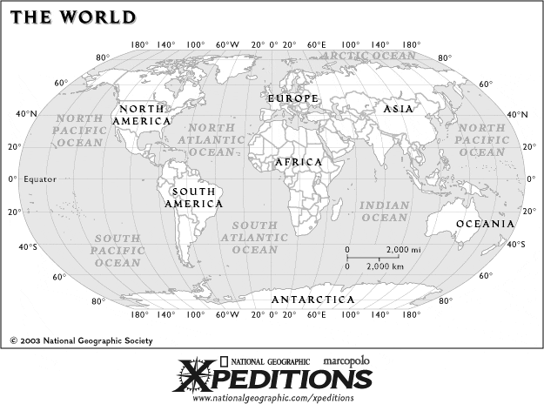
- What continent is at 0° longitude and 0° latitude? Africa

- If a map scale had a ratio of 1 in : 10 miles. How many miles would you travel in 3 inches? 30 miles

BCR Question
Which is a better representation of the Earth, a globe or a map? Why?

