Getting your students signed up

Creating free accounts on Quizlet is quick and easy! We recommend asking your students to sign up for their own accounts so that they can continue to use Quizlet from year to year and for all subjects. Once your students have accounts they will be able to track their own progress and scores.

How to sign up
Ask your students to click "Sign Up" in the blue Quizlet header.

Students can create an account by entering their birthday, a username, a valid email address and a secure password (If your child is under the age of 13 and you want them to have their own account they will need their own email account and on Quizlet you will need to enter a birthday year that would make them 13 or see directions on the following pages for using your email account)

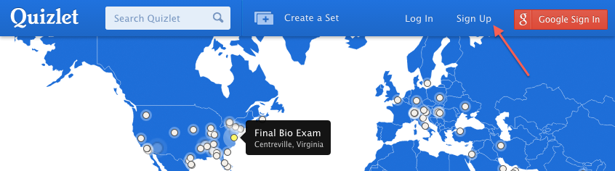
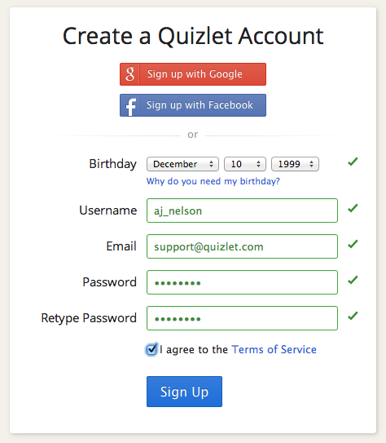

Tip: You can ask them to create a username that reflects their real name, so you can easily identify them on Quizlet.
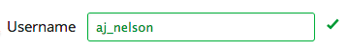
If your students use Google Apps for Education or Gmail, they can sign up using their Google username and password by clicking on the red "Sign up with Google" button

.
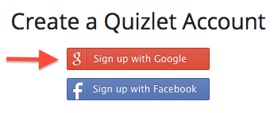

* Accounts for students under 13
If your students are under 13, they will be asked for a parent's email address during sign up. Password resets and Quizlet support responses will go to this email address. Learn more about accounts for users under 13.

